**Steps to follow drugs to place an order online**

**Overview**

Online shopping provides ease of access to the consumers, Significantly purchasing Rx prescriptions and OTC( Over counter) drugs which helps the patients to deliver their new prescriptions, and refill their drugs at their fingertips. Most well-known, corporate pharmacies provide online facilities. In India, there are various drug marts platforms such as Medplus, 1mg, Apollo pharmacy, and netmeds.

**Example:** Purchasing medicines online through Apollo 247:<https://www.apollopharmacy.in/>

1. Open browser ( IE, Chrome, Mozilla), type <https://www.apollopharmacy.in/> and connect to the Apollo webserver.

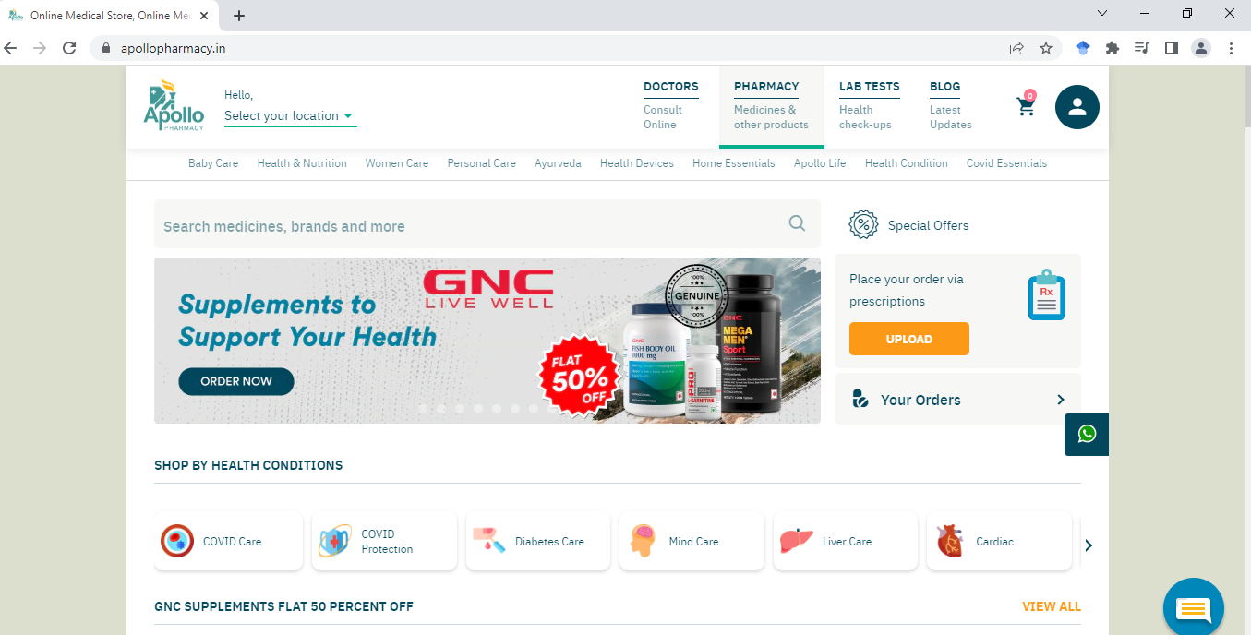

1. Update your location to retrieve and dispatch your products in time.



1. Type the prescribed medicines from the search box, and select the appropriate strength, quantity, and brand.



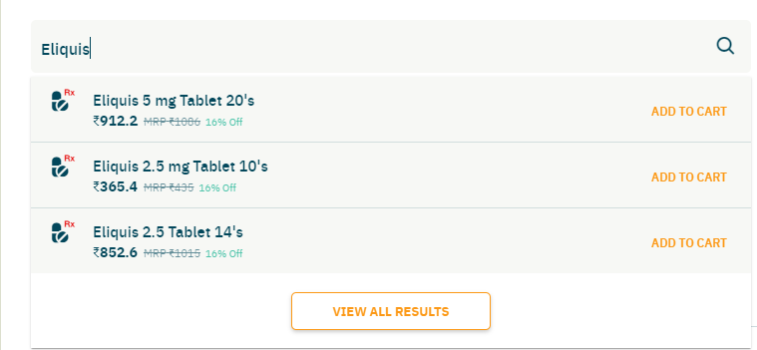

1. Select the appropriate qty, Eliquis 2.5 mg with Qty 10, the number of strips, provide your delivery location and click add to cart.

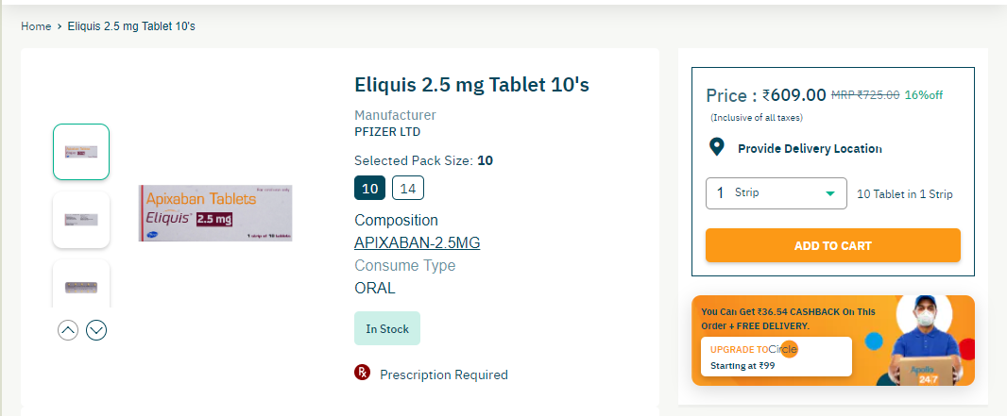

1. Go to cart, click special offers and discount coupons to apply appropriate discounts.

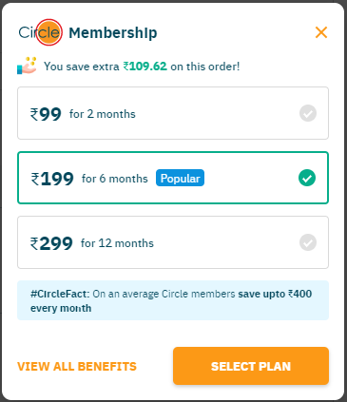 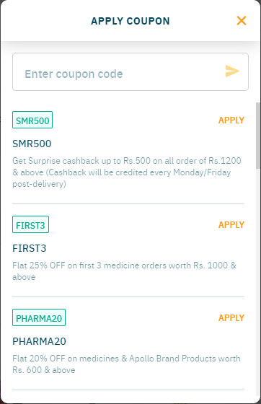

1. Click to proceed to the payment page, and upload your prescription.

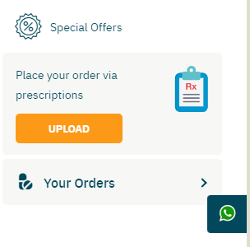

1. Select the appropriate payment option and complete the process.

**Conclusion**

Purchasing prescription drugs online provides ease of access for the patients to deliver their products at home. Online pharmacies enhance more options such as refills, reminders to purchase, free delivery, discount coupons, and offers.